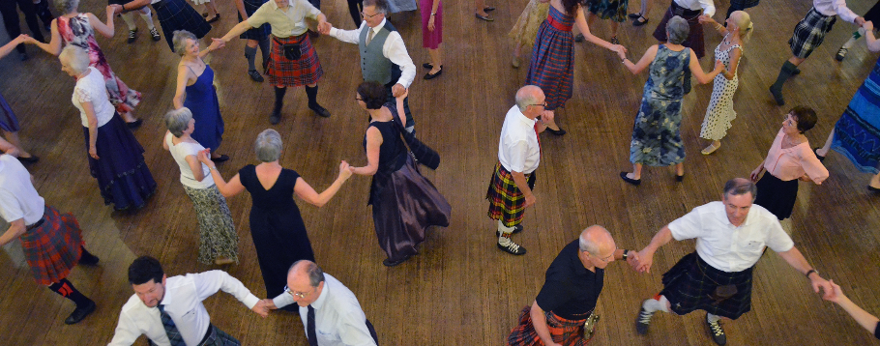

COME & DANCE WITH US

FRIDAYS

19:00 – 20:00

SUMMER 1st Month – 31st Month 2016

AUTUMN 1st Month – 31st Month 2016

WINTER 1st Month – 31st Month 2016

SPRING 1st Month – 31st Month 2016

YOUR BRANCH NAME & ADDRESS

12 Coates Crescent, Edinburgh, EH3 7AF / +44 (0)131 225 3854 / info@rscds.org

Promoted by the Royal Scottish Country Dance Society

Registered Scottish Charity No. SC 016085 Company No. SC 480530

£3 per class paying in advance, £4 per class pay as you go

Location of classes,

Address with postcode

WWW.RSCDS.ORG

RSCDS BRANCH NAME GOES HERE