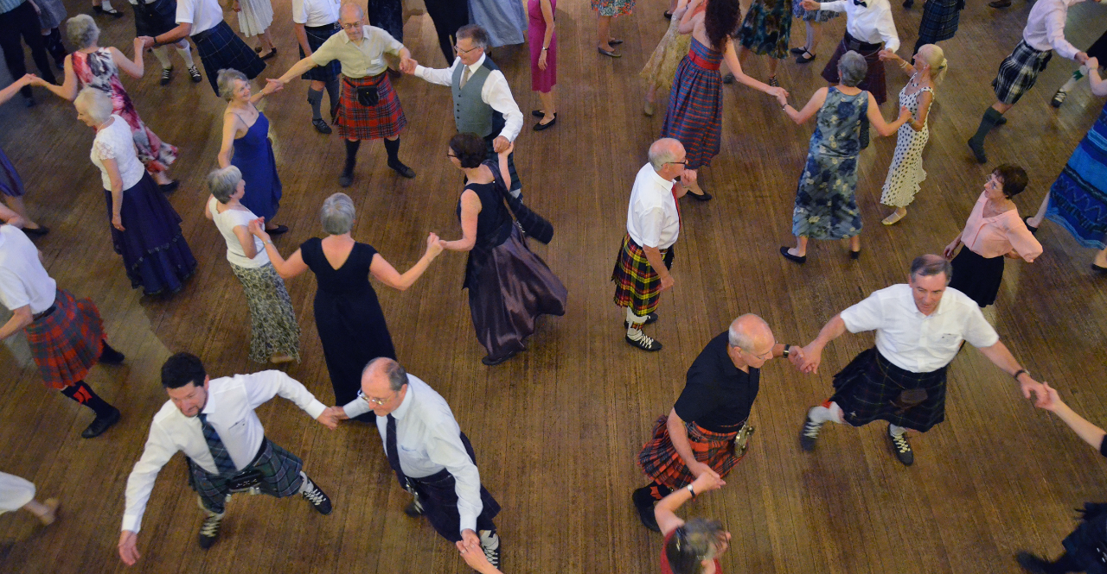

WWW.RSCDS.ORG

RSCDS BRANCH NAME GOES HERE

Promoted by the Royal Scottish Country Dance Society Registered Scottish Charity No. SC 016085

Company No. SC 480530

YOUR BRANCH NAME & ADDRESS

12 Coates Crescent, Edinburgh, EH3 7AF

+44 (0)131 225 3854

Lorem ipsum dolor sit amet, consectetuer adipiscing elit, sed diam nonummy nibh euismod tincidunt ut laoreet dolore magna aliquam erat volutpat. Ut wisi enim ad minim veniam, quis nostrud exerci tation ullamcorper suscipit lobortis nisl ut aliquip ex ea commodo consequat. Duis autem vel eum iriure dolor in hendrerit in vulputate velit esse molestie consequat, vel illum dolore eu feugiat nulla facilisis at vero eros et accumsan et iusto odio dignissim qui blandit praesent luptatum zzril delenit augue duis dolore te feugait nulla facilisi. Nam liber tempor cum soluta nobis eleifend option congue nihil imperdiet doming id quod mazim placerat facer possim assum.

COME & DANCE WITH US