

RSCDS Archive
Acquisitions and Disposition Policy and Form

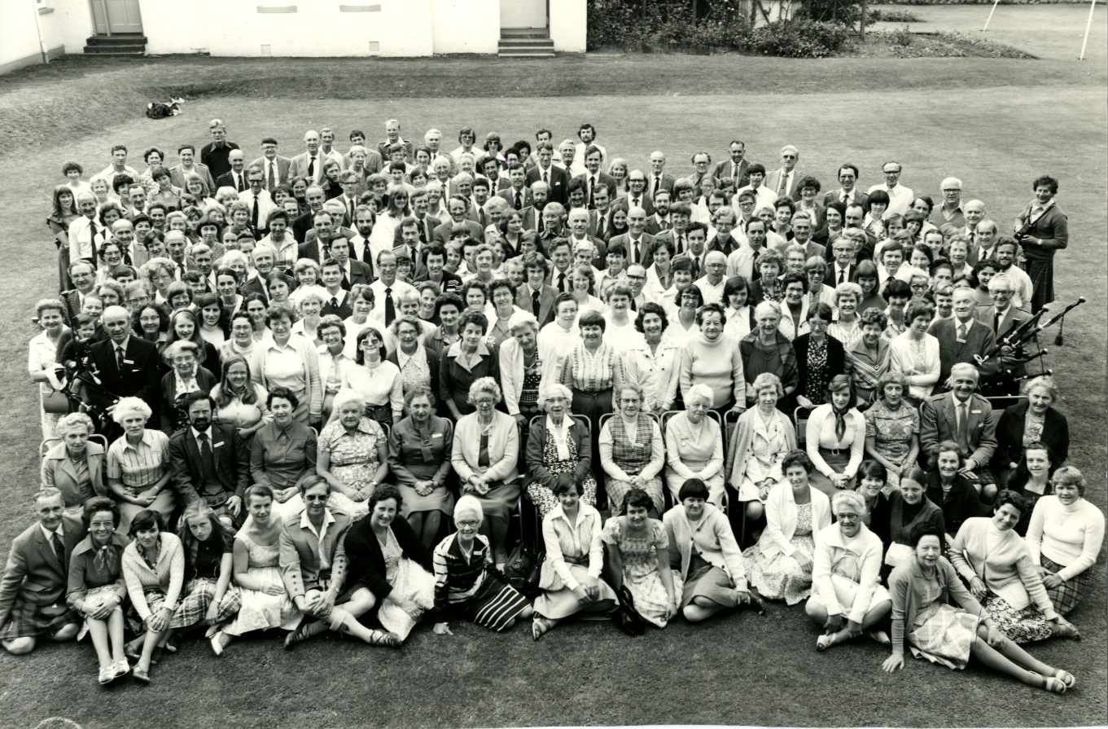

RSCDS Archive

We aim to identify, collect, preserve and provide access to archives and publications which are of historical significance to the development of RSCDS and Scottish country dancing.

Collection Policy
RSCDS Archives collects;

- Administrative records of RSCDS head office, Branches and Affiliated Groups and SCD Clubs.
- Personal papers of RSCDS members and staff relating to Scottish Country Dancing.

This includes photographs, film, sound recordings and objects as well as written documents.

Terms of Deposit

Accepting Deposits
- RSCSD Archives will only accept deposits which are compatible with its collection policy.
- RSCDS Archives will only accept deposits from those whose rights to transfer ownership have been established.

Copyright
Unless otherwise agreed the depositor assigns to RSCDS all copyright and intellectual rights in the material.

Preservation
RSCDS Archives will take all reasonable care to preserve records from theft, loss or destruction but beyond this will not be liable for any loss or damage.

Conservation
RSCDS Archives will be entitled to take any of the following actions in respect of deposited records:
- To photograph, scan, or otherwise copy them as a conservation measure.
- To number them in a non-permanent manner with a finding reference for their identification and safe-keeping.
- To carry out such work in regard to the conservation of the records as is considered necessary to prevent deterioration.

Disposal
RSCDS Archives reserves the right to return items to Donors if such persons can be traced following reasonable enquiry or to dispose of the items in their absolute discretion.

Cataloguing
Deposited records will be catalogued as part of RSCDS Archives’ programme of cataloguing all collections in its custody and in accordance with the best current practice. A copy of the finished printed catalogue will be provided to the depositor, if requested. As there is a backlog of cataloguing it may not be possible to catalogue the records immediately.

Access
- RSCDS Archives will make the material available to researchers, in person and on the internet, subject to any restrictions agreed between the depositor and the archives and such disclosures as required by legislation e.g. The Data Protection Act (1998) ), Freedom of Information Act (2000).
- The depositor authorises RSCDS Archives to exhibit the material as it sees fit.
- The depositor authorises RSCDS Archives to supply copies of material to researchers.

RSCDS Archive Donation Form

Donor Details
Name:
Address:
Email:
Transfer date:
RSCDS Branch/ office/ Affiliated Group:
(if applicable)
Donation Details
Title:

Covering dates:
Number of items:
Description:
Access Restrictions:
(if applicable)
Copyright Assignment  (Delete as Applicable) | - I agree that the copyright of the above described items is assigned to the RSCDS.  - I retain the copyright of the above described items.

I hereby donate the scheduled items upon the terms and conditions set out above

Signed by the DONOR:
Date:

Signed for the ARCHIVE:
Date:

RSCDS Archive Staff use
Received by
Accession Number

